Project Design Phase-II

Data Flow Diagram & User Stories
Date: 31 January 2025
Team ID: LTVIP2026TMIDS91486
Project Name: HematoVision – Intelligent Blood Cell Classification System
Maximum Marks: 4 Marks

Data Flow Diagrams
A Data Flow Diagram (DFD) represents how data moves through the HematoVision system. It illustrates inputs, processing stages, outputs, and storage components.

✅ DFD Level 0 (Context Diagram) 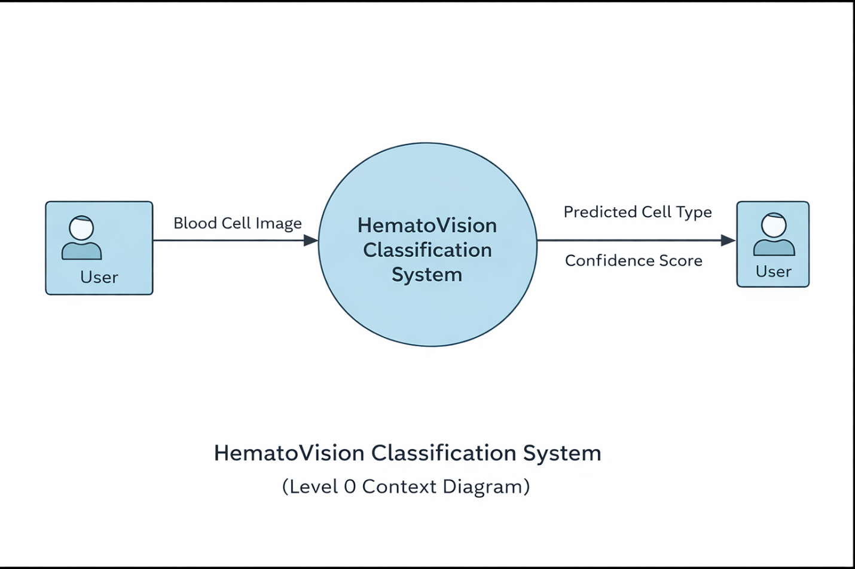

DFD Level 1 (Simplified System Flow) 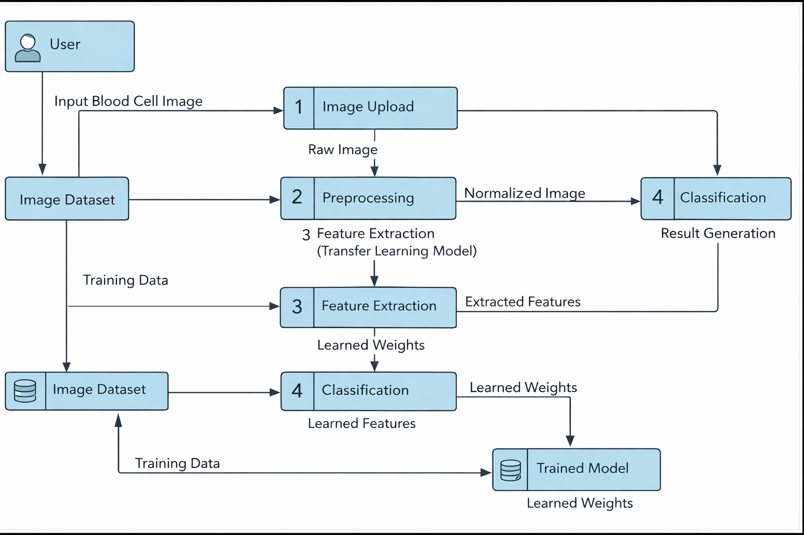

User Stories
User Type | Functional Requirement (Epic) | User Story Number | User Story / Task | Acceptance Criteria | Priority | Release
End User (Web App User) | Image Upload | USN-1 | As a user, I can upload a blood cell image to the system for analysis. | ✔ User can select image ✔ Supported formats accepted ✔ Image successfully displayed | High | Sprint-1
End User (Web App User) | Image Validation | USN-2 | As a user, I receive an error message if an invalid image is uploaded. | ✔ Invalid files rejected ✔ Error message displayed | High | Sprint-1
End User (Web App User) | Prediction | USN-3 | As a user, I can run classification on the uploaded image. | ✔ Prediction triggered ✔ Processing indicator shown ✔ Output generated | High | Sprint-1
End User (Web App User) | Results Display | USN-4 | As a user, I can view the predicted blood cell type. | ✔ Predicted label shown ✔ Clear UI presentation | High | Sprint-1
End User (Web App User) | Confidence Score | USN-5 | As a user, I can see prediction confidence. | ✔ Probability / confidence visible | Medium | Sprint-2
Researcher / Developer | Model Training | USN-6 | As a developer, I can train the transfer learning model using dataset images. | ✔ Dataset loaded ✔ Training executes ✔ Model saved | High | Sprint-1
Researcher / Developer | Model Evaluation | USN-7 | As a developer, I can evaluate model accuracy. | ✔ Accuracy metrics generated ✔ Loss values displayed | High | Sprint-1
Researcher / Developer | Model Improvement | USN-8 | As a developer, I can fine-tune the pretrained CNN model. | ✔ Layers configurable ✔ Updated model saved | Medium | Sprint-2
Administrator | System Monitoring | USN-9 | As an administrator, I can monitor system performance. | ✔ Logs available ✔ Prediction activity tracked | Low | Sprint-3

